* **Communication**
* Communication is the process of transferring information, ideas, message, emotions, feelings from one person to another person. It is also a transfer of meaning and understanding between two or more people through verbal and nonverbal means. It is one of the important managerial functions. Communication is a continuous and pervasive function of management. It will continue up to the existence of the organization and exist in every part of management.
* Communication is a process of transmitting thoughts, opinions, messages, facts, ideas or emotions with proper understanding. It helps to understand people better, remove misunderstanding, and create clarity of thoughts and expression. It is one of the important management function closely related to all the other managerial functions. It minimizes the gap between two parties through information and understanding between them.
* **Features of communication:**
* 1. Two parties
* 2. Two way process
* 3. Pervasive function
* 4. Formal and informal
* 5. Oral and written
* 6. Continuous process
* 7. Complete process
* 8. Human process
* **Importance of communication**
* 1. Basic function of management
* 2. Successful operation of business
* 3. Facilitates coordination
* 4. Employees morale and motivation
* 5. Support to manage resistance to change
* 6. Healthy human relation
* 7. Establish public relation
* **Process of communication:**
* 
* **Types of communication**

Types of   
Communication

Horizontal

Vertical

Diagonal

Horizontal

**Horizontal communication**

Communicationthat takes place at the same level of hierarchy in an organization is called horizontal communication. Communications between peers, between managers at the same level or between any horizontally equivalent organizational members are the examples of horizontal communication.



Features :

* Time saving.
* It facilitates coordination of tasks.
* It fosters the cooperation among team members.
* It provides emotional and social assistance to the organizational members.
* Helpful in solving various organizational problems.
* Easy ways of information sharing.
* It can also be used for resolving conflicts of a department with other departments or departmental conflicts in various issues.

**Vertical Communication:**

* Vertical communication flows vertically upwards or downwards through the formal organizational chain of command. Upward communication is the flow of communication from subordinates to managers and downward communication flows from a superior to a subordinate. Vertical communication can be classified as:



Downward communication:

* Communication that flows from a higher level in organization to a lower level is called downward communication. In other words, communication from superiors to subordinates in a chain of command is a downward communication. Such types of communication is used by the managers to send work related information and orders to the employees at lower levels. Employees require these kinds of information for performing their regular jobs and for meeting the expectations of their managers. Organizational publications, circulars, letter to employees, group meetings, etc. are the examples of downward communication. Basically, downward communication is used by the managers for the following benefits and purposes.
* Providing feedback on employees performance.
* Giving job instructions.
* Highlighting the areas of attention.
* Communicating the organizational mission, vision and objectives to the employees and so on.

Upward communication:

* Communication that moves to a higher level from the lower level in an organization is called upward communication. It provides feedback on the organization functioning. The subordinates use upward communication to convey their problems and performances to their bosses. It can also be used by the employees to share their views and ideas and to participate in the decision making process with the managers. Grievance system, complaint and suggestion box, job satisfaction survey, etc. are some examples of upward communication. Upward communication helps organization to improve its decisions.

Diagonal Communication:

* Communication that take places between a manager and employees of other working groups is called diagonal communication. It generally does not appear on the organizational chart. For instance, to design training module, a training manager interacts with an operations level personnel, rather than training department, to enquire about the way they perform their tasks and determines the training needs and methods.



**Barriers to effective communication:**

1. Physical barrier

i. Noise

ii. Distance

iii. Physical arrangement

1. Psychological barrier

* i. Perception
* ii. Distrust
* iii. Filtering
* iv. Viewpoint
* v. Defensiveness
* vi. Inadequate attention

1. Semantic barrier
2. Meaning of language

ii. Jargon

1. Technical languages
2. Organizational barrier

i. Poor planning

ii. Complex structure

iii. Status difference

iv. Timing

v. Information overload

vi. Lack of feedback

1. Technological barrier

**Ways of enhancing effective communication.**

## 1. Be clear and concise

Communication is primarily about word choice. And when it comes to word choice, less is more.

The key to powerful and persuasive communication — whether written or spoken — is clarity and, when possible, brevity.

Before engaging in any form of communication, define your goals and your audience.

Outlining carefully and explicitly what you want to convey and why will help ensure that you include all necessary information. It will also help you eliminate irrelevant details.

## 2. Prepare ahead of time

Know what you are going to say and how you are going to say before you begin any type of communication.

However, being prepared means more than just practicing a presentation.

Preparation also involves thinking about the entirety of the communication, from start to finish. Research the information you may need to support your message. Consider how you will respond to questions and criticisms. Try to anticipate the unexpected.

## 3. Be mindful of nonverbal communication

Our facial expressions, gestures, and body language can, and often do, say more than our words.

Nonverbal cues can have between [65 and 93 percent more impact](https://www.forbes.com/sites/jacquelynsmith/2013/03/11/10-nonverbal-cues-that-convey-confidence-at-work/?sh=49f95bf05e13) than the spoken word. And we are more likely to believe the nonverbal signals over spoken words if the two are in disagreement.

Leaders must be especially adept at reading nonverbal cues.

## 4. Watch your tone

How you say something can be just as important as what you say. As with other nonverbal cues, your tone can add power and emphasis to your message, or it can undermine it entirely.

## 5. Practice active listening

Communication nearly always involves two or more individuals.

Therefore, listening is just as important as speaking when it comes to communicating successfully. But listening can be more challenging than we realize.

## 6. Build your emotional intelligence

Communication is built upon a foundation of emotional intelligence. Simply put, you cannot communicate effectively with others until you can assess and understand your own feelings.

“If you

Leaders with a high level of emotional intelligence will naturally find it easier to engage in active listening, maintain appropriate tone, and use positive body language.

## 7. Develop a workplace communication strategy

Today’s workplace is a constant flow of information across a wide variety of formats. Every single communication must be understood in the context of that larger flow of information.

Even the most effective communicator may find it difficult to get their message across without a workplace communication strategy.

## 8. Create a positive organizational culture

The corporate culture in which you are communicating also plays a vital role in effective communication. In a positive work environment — one founded on transparency, trust, empathy, and open dialogue — communication in general will be easier and more effective.

**Group**

A Group is basically an assemblage of people. It can be understood as a collection of individuals (two or more), who come together and interact with each other, so as to achieve the objectives of the [organization](https://businessjargons.com/organization.html). These are the foundation of an organization.

**Characteristics of group**

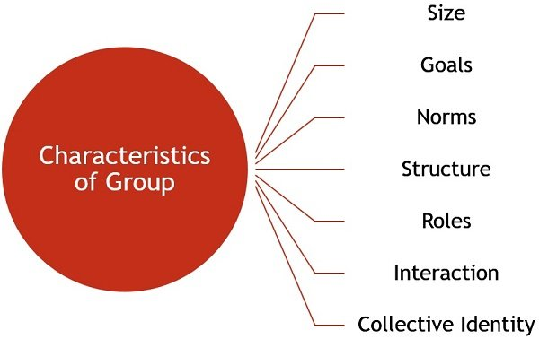

* **Size**: To form a group, it must be having at least two members. Practically, the number of group members ranges from 15 to 20. The more the members in the group, the more complex it is to manage.
* **Goals:** Every group has certain goals, that are the reasons for its existence.
* **Norms**: A group has certain rules, for interacting with the group members.
* **Structure**: It has a structure, based on the roles and positions held by the members.
* **Roles**: Every member of a group has certain roles and responsibilities, which are assigned, by the group leader.
* **Interaction**: The interaction between the group members can occur in several ways, i.e. face to face, telephonic, in writing or in any other manner.
* **Collective Identity**: A group is an aggregation of individuals, which are separately called as members, and collectively called as a group.

## [Types of Groups](https://businessjargons.com/types-of-groups.html)

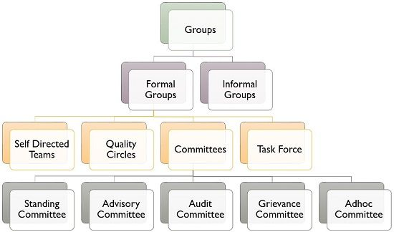

* [**Formal Groups**](https://businessjargons.com/formal-groups.html): Groups that are formed consciously by the [management](https://businessjargons.com/management.html), with an aim of serving an organizational objective. These are further classified as:
  + **Self-directed teams**: The group of employees which are so authorised to make decisions, on their own, as it is independent and self-governing in nature.
  + [**Quality Circles**](https://businessjargons.com/quality-circle.html): A number of employees classed together belonging to the same field, who meet every week for an hour, to talk about their problems, identify the causes and find out solutions, to take necessary steps in this regard.
  + [**Committees**](https://businessjargons.com/committees.html): An association of people created by the management for different matters to identify and discuss the issues of the company and arrive at a conclusion. It can be:
    - Standing Committee
    - Advisory Committee
    - Audit Committee
    - Grievance Committee
    - Adhoc Committee
  + [**Task force**](https://businessjargons.com/task-force.html): It is a temporary committee, wherein people belonging to different fields are grouped together for the performance of the task.
* [**Informal Groups**](https://businessjargons.com/informal-groups.html): The social and psychological variables operating at the workplace, results in the formation of informal groups. The creation of these groups is spontaneous due to the common interest, social needs, physical proximity and mutual attraction.

## Reasons for Group Formation

* **Personal Characteristics**: Individuals with similar beliefs, attitudes and values are more likely to form groups.
* **Opportunity for interaction**: If the employees of an organization, are given an opportunity to interact with one another, they find that they have many things similar, which also creates a group.
* **Interest and goals**: When individuals share common interests and goals, it requires cooperation and coordination for its achievement, which also results in the formation of groups.
* **Influence and power**: Last but not the least, a group has more influence and power, as compared to an individual, which also promotes its formation.

**Team**

* A team can be defined as [a group of people](https://tyonote.com/group/)who interact and influence each other for the achievement of a common purpose. Team members are mutually accountable for achieving [common objectives.](https://tyonote.com/organizational_goals/)
* The best definition of a team may be, when, members are the backbone to each other, members are sure they will get the same response as they provide, builds synergy, everyone is optimistic, and no one left the ground until the goal is achieved.

## Characteristics of Team

An effective work team is characterized by its following attributes.

### Diverse Expertise

A team comprises a small group of individuals who possess different skills that complement one another, allowing them to tackle various aspects of a project or problem effectively.

### Shared Objectives

All team members must align and work towards [common goals,](https://tyonote.com/objective/) ensuring everyone is on the same page and focused on achieving the desired outcomes.

### Empowered Autonomy

Teams are self-directed, autonomous, and self-managing entities, empowered[to make decisions](https://tyonote.com/decision_making_process/) and take responsibility for their actions without constant supervision.

### Individual and Collective Responsibility

Each team member is accountable for their own contributions and actions, while also embracing mutual accountability to foster a sense of ownership and ensure collective success.

### Unified Commitment

A team demonstrates tireless dedication and unity toward the accomplishment of shared objectives, fostering a collaborative environment where everyone is committed to achieving success.

### Effective Communication

Two-way [communication](https://tyonote.com/communication/) channels are established within the team, facilitating open dialogue, active listening, and understanding among members, leading to better collaboration and [problem-solving](https://tyonote.com/problem_solving/).

### Synergy and Coordination

Through [coordinated](https://tyonote.com/importance-of-coordination/) efforts, a team generates synergy by leveraging the collective strengths and skills of its members, creating a harmonious and amplified effect that enhances overall productivity and outcomes.

### Leadership Roles

Within the team, specific individuals take on [leadership roles](https://tyonote.com/democratic-leadership/), guiding and directing the team toward goal achievement, providing guidance, and support, and fostering a positive team dynamic.

**Types of Team**

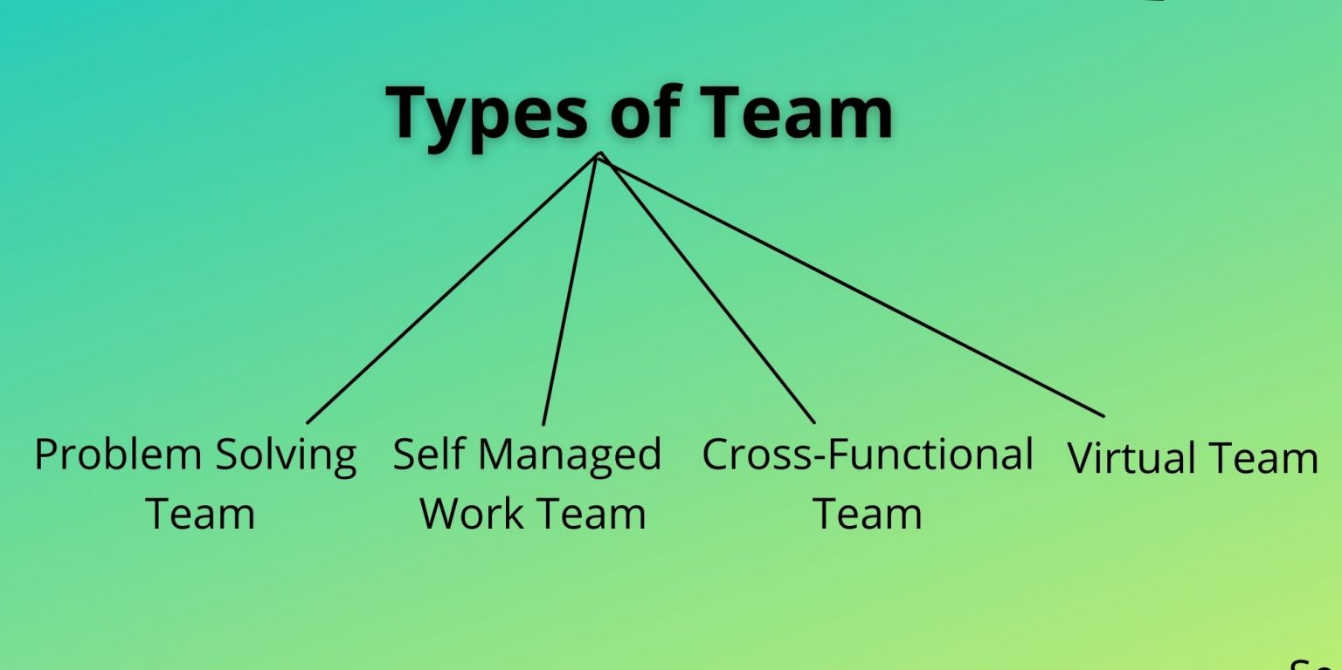

### Problem-Solving Team

As the name implies, teams are formed to solve organizational problems. [Problem-solving](https://tyonote.com/problem_solving/) teams are composed of 5 to 12 employees from the same department to improve quality, efficiency, and work environment.

In problem-solving teams, members share ideas or offer suggestions on how work processes and methods can be improved. Members are not fully independent, they can offer suggestions but can not force implementation.

[Quality circle](https://tyonote.com/quality_of_work_life/) falls in this category. Quality circles are small teams of employees consisting of 8 to 10 members, who share an area of responsibility. They meet regularly to discuss their problems, investigate the cause of problems, recommend solutions, and take corrective actions. They assume the responsibility for solving quality problems and evaluate their own feedback.

### Self-Managed Team

A self-managed team is a formal group of employees that operates without [a manager.](https://tyonote.com/what-is-manager/) These are the small group of employees, typically 10 to 15 number, who perform highly related or independent jobs and bear the responsibilities of their supervisors.

[Self-managed](https://smallbiztrends.com/2018/11/self-managed-teams.html) team member’s jobs include planning and scheduling of work, assigning tasks to members, collective control over the pace of work making operating decisions, and taking action on problems.

Fully self-managed work teams pick their own members and have the members assess each other’s doing. As a result, supervisory positions will have little importance and may even be eliminated.

### Cross-Functional Teams

Cross-functional teams consist of employees from about the [same hierarchal level](https://tyonote.com/levels_of_management/#:~:text=In%20every%20organization%20there%20are,%2C%20capability%2C%20and%20authority%20level.)but different work areas in an organization. This is an effective means for employees from diverse areas within an organization to exchange information, develop new ideas, solve problems, and coordinate complex tasks.

The diverse work team can help identify creative or unique solutions. It takes time to build trust and teamwork, especially among those from different backgrounds with different experiences and perspectives. [Committees and task forces](https://tyonote.com/committee_organization/) are examples of cross-functional teams.

### Virtual Teams

A virtual team uses [computer technology](https://tyonote.com/personal_computer/) to tie together physically dispersed members to achieve a common goal. It allows groups to meet without concern for space and enables organizations to link workers together in a way that would have been impossible in the past.

Virtual teams can do all the things that other teams do share information, make decisions, and complete tasks. Its members use technological advances, like video conferencing, email, zoom meetings, Microsoft Teams meetings, the Internet, etc.

Virtual teams do coordinate work and take decisions fairly and efficiently. Its members can do their work even if they are far apart and spread in different geographical locations.

## Difference Between a Team and a Group

|  |  |
| --- | --- |
| **Group** | **Team** |
| [Group has a](https://tyonote.com/group/)strong, clearly focused leader. | The team has shared leadership goals. |
| Individual accountability. | Individual and mutual accountability. |
| The group’s purpose is the same as the broader organizational mission. | Specific team purposes that the team itself delivers. |
| Runs efficient meetings. | Encourages open-ended discussion and active problem-solving meetings. |
| Individual work products. | Collective work products. |
| Neutral synergy (sometimes negative). | Positive synergy. |
| Random and varied skills. | Complementary skills. |

**Conflict Management:**

* Conflict is the disagreement between two or more individuals, group or organizations.
* Conflict management is the process of identifying and handling conflicts fairly and efficiently. Conflict can be positive and leading to higher productivity in organization. It is the natural phenomenon in an organization. So, the manager should clearly understand the situation of conflicts and its consequences and try to manage them as far as practicable.

**Types of conflict**

Level/ Types of Conflict

**Individual Level Conflict**

a. Intra-individual conflict

b. Inter-personal conflict

**Group- Level Conflict**

a. Intra-group conflict

b. Inter-group conflict

**Organizational Level Conflict**

a. Intra-organizational conflict

b. Inter-organizational conflict

**Techniques of conflict management in an organization:**



**1. Stimulating conflict: There are a number of ways for stimulating conflict.**

* Increase competition among individuals and teams.
* Hire outsiders
* Change established procedures.
* Communication
* Reorganizing and restructuring

**2**. **Preventing conflict:** The major methods of preventing conflicts are:

* Expand resource base
* Enhance coordination of inter -dependence
* Set super ordinate goals
* Match personalities and work habits of the employees.
* Exchange of personnel.
* Appeal to higher authority

**3. Resolving and eliminating conflict: The** major methods of resolving conflicts are listed below:

* Avoid conflict
* Convince conflicting parties to compromise
* Bring conflicting parties together to confront and negotiate conflicts
* Problem solving
* Accommodating something.

**Process of Conflict management**

Preparation and planning

Definition of ground rules

Clarification and justification

Bargaining and problem solving

Closure and implementation